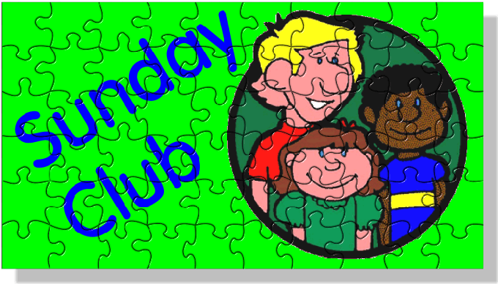
Rochester Cathedral Sunday Club
Summer Term 2024

Dear Parents,

A belated welcome back to you and your children after the Easter Holidays. Thank you to all who have supported the various events and special services held last term and a special thanks to all those who helped it all happen. Here are the events for the summer term.

Pentecost Junior Worship Sunday 19th May 10.30am

We will aim for this to be outdoors, weather depending, so please ensure you have appropriate footwear a jumper, or sunscreen/ sunhat depending what weather May brings!

Frogs Outing to see Jesus Christ Superstar- Saturday 22nd June 6pm

The renound musical “Jesus Christ Superstar” by Andrew Lloyd Webber and Tim Rice is on tour and will be on at the Marlowe in Canterbury on June 22nd, 2024, starting at 7.30pm. We would like to take the Frog’s group (children aged 11 and over). We will travel to Canterbury via the train and will aim to get a group ticket. Until we know numbers, we don’t know if we can get a group discount for the show, but ticket prices are £75 at full price. Until I know numbers, I am unable to give a total price, but worst-case scenario will be £80/ child and hopefully a bit cheaper. Please complete the form below to register your interest and get these to me ASAP (by Sunday 5th May at the latest).

First Communion Service
Sunday 23rd June 10.30am

This is an all-age worship in the Nave and please do come and support all those who will be receiving Communion for the first time. There will be no Sunday Club this week.
If your child aged 7 and over is interested in joining the exploring communion course, then please let me know.

Sunday Club summer games in the Garth Sunday 7th July 10.30am (during the morning service)

All Sunday Club children are invited to a summer fun morning of games in the Garth with a small party in the Garth access via the Collier Fergusson room). Please ensure your child has appropriate clothing for the weather, including sunscreen and a hat.

Sunday Club Summer Holidays

Sunday club will be closed from 14/7/24 to 1/9/24 inclusive, so the first Sunday back will be
Sunday 8th September 2024

Calling parents to join the Sunday Club Staff Team….!!

We are desperate for some extra help due to several vacancies on the staff team and for the Sunday Club to continue running, next term, we need you! If any parent feels they could commit to one Sunday a month to help with Sunday Club, I would be very grateful. The recruitment process takes a bit of time and commitment but please stick with it. If interested, please Email me, I’d be delighted to hear from you.

A few reminders:

During the Sunday Club holidays, the Crypt is out of bounds to Sunday Club children and young people. If you are unsure if it is holidays, then please check with me, a member of the Sunday Club team, or a Verger.

The weekly session ends with the children being brought up to Communion by the Sunday Club Staff. Some parents like to receive Communion with their children, in which case, please do join the group as we enter the Nave. After Communion, we aim to return the children to you.

Lastly, just to remind you that the Cathedral is a public space and there is no means of knowing who enters the building or attends worship, so please watch your children and your possessions whilst in the Cathedral.

Any queries/ concerns, please contact Sugina.

Looking forward to seeing you and your children

Warm wishes
Sugina Hesketh
suginahesketh@btinternet.com
01634 810073 07759951057

